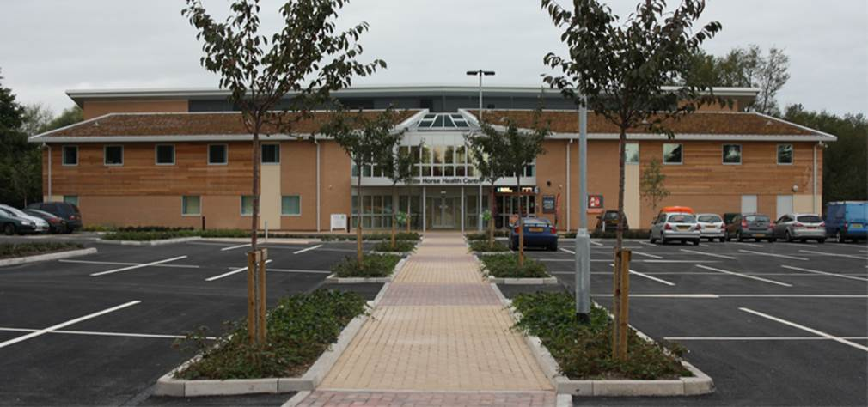

# **The Westbury Group Practice**

**We are delighted to offer fantastic opportunities to join our team in this semi-rural practice between Bath and Salisbury as a Salaried GP / remote GP – Salary very competitive**

* Rated “Good” overall by CQC.
* The Westbury Group practice is located over two sites : The White Horse Health Centre in Westbury and our dispensing branch surgery in Bratton.
* This role will be primarily based at our modern purpose built surgery, The White Horse Health Centre in Westbury.
* Remote working opportunities
* Good progression opportunities
* PMS Practice with over 22,500 patients.
* We are a proud to be a Training Practice and we offer the opportunity to be involved in teaching of both GP Registrars and medical students.
* Advanced Nurse Practitioners and paramedic assisting with on the day care.
* Efficient and highly supportive administrative teams.
* Innovation and new ideas welcome.
* Personal development and special interests encouraged and supported.
* Formal mentorship and educational support.
* Democratic and friendly team.
* Flexible working pattern.
* System One clinical system used.
* Terms and conditions equal to BMA Model Salaried GP contract.
* Defence Union Fees paid.
* Good schools locally.

If you are an enthusiastic, friendly GP,

we would love to meet you!

Application with cv to:

## Mark Dickson, Managing Partner,

**Westbury Group Practice**

**White Horse Health Centre**

**Mane Way, Westbury, Wiltshire, BA133FQ**

**Tel: 01373 828342/828341**

**Email:** [**mark.dickson1@nhs.net**](mailto:mark.dickson1@nhs.net)

**www.westburygp.co.uk**